Tianle Yuan
CS 550
November 11, 2020
Project 5

Name: Tianle Yuan
Email: yuant@oregonstate.edu
Project Number: 5
Project Name: Shaders
Web Link: https://media.oregonstate.edu/media/1_nufdol02
Screen Captures：

The stationary graphic without changing of variables of both vertex shader and fragment shader.
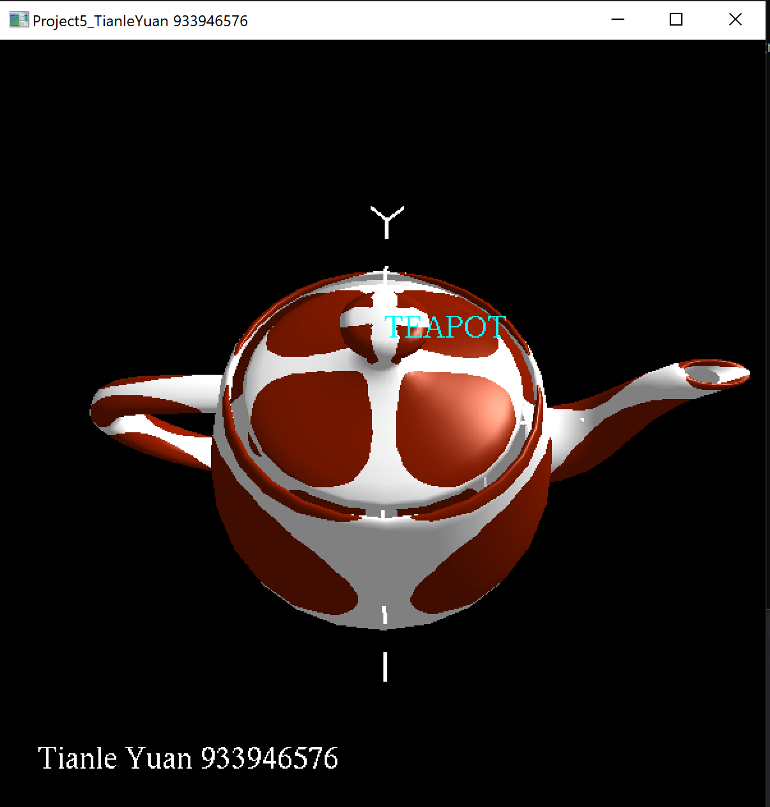
When we start to change the variable of the vertex shader, but freezing the fragment shader.
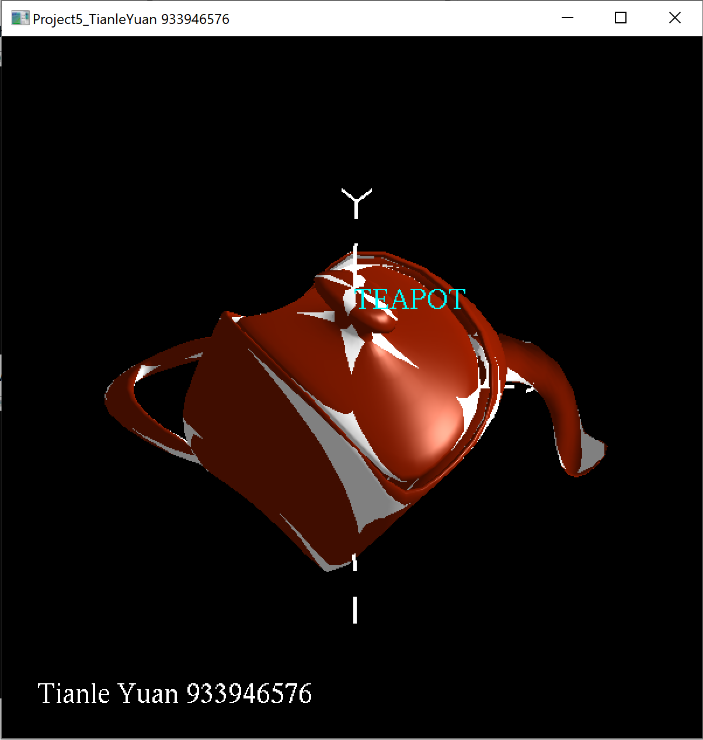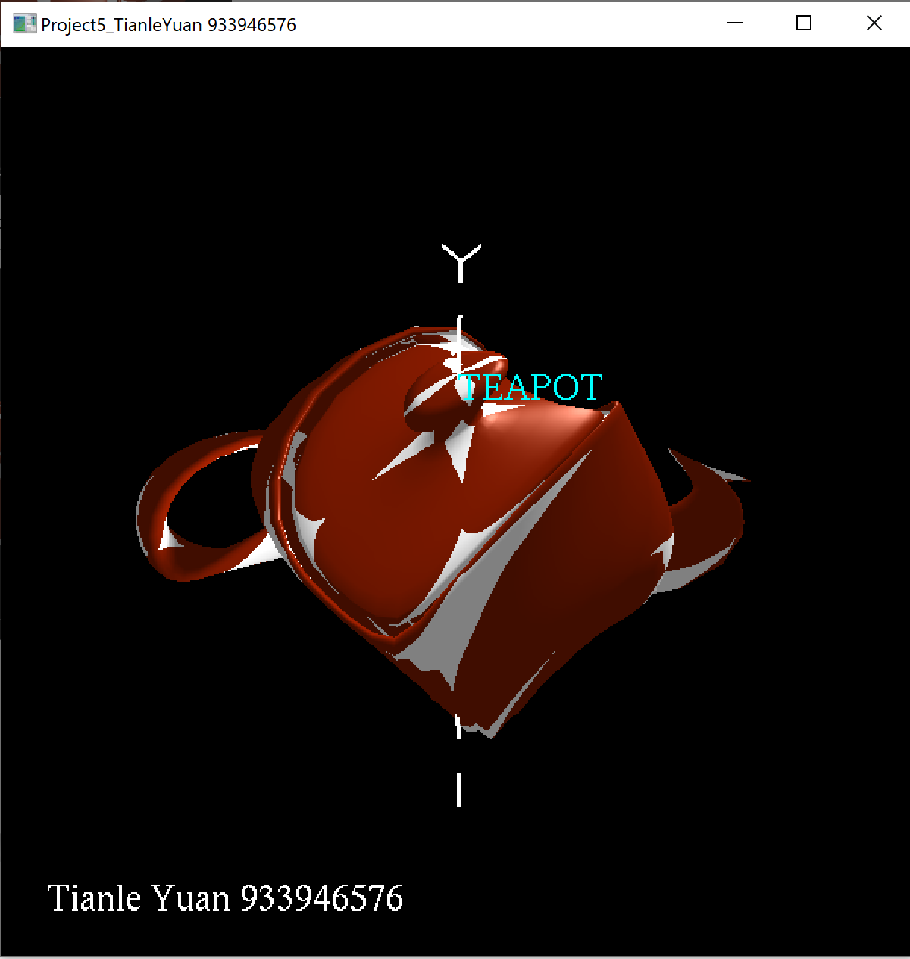

When we start to change the variable of the fragment shader, but freezing the vertex shader.
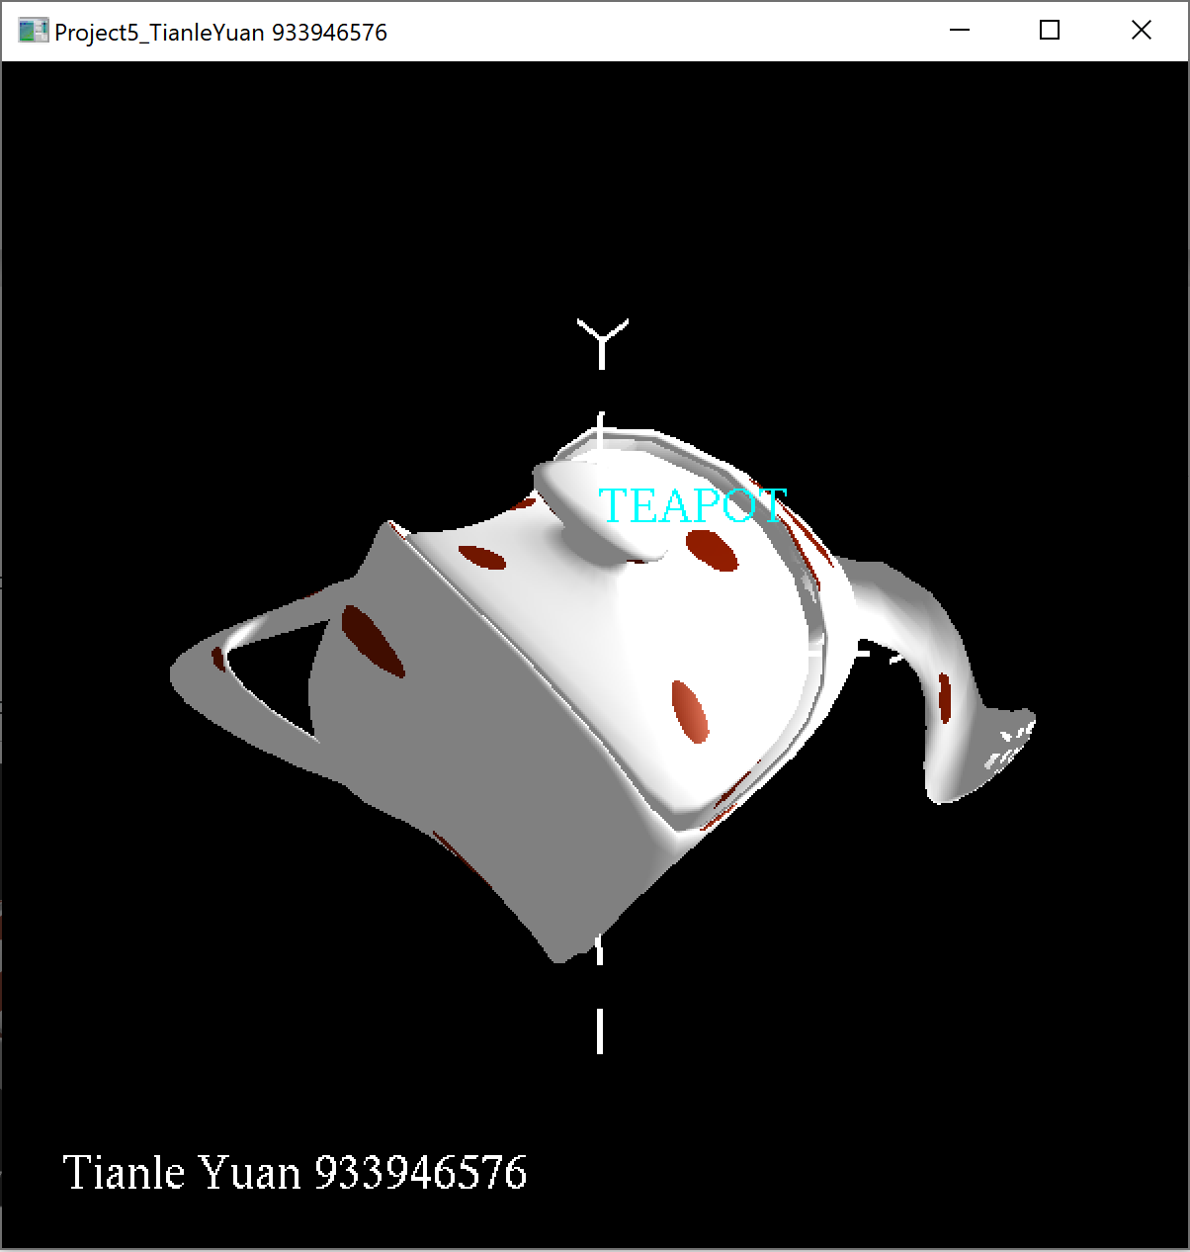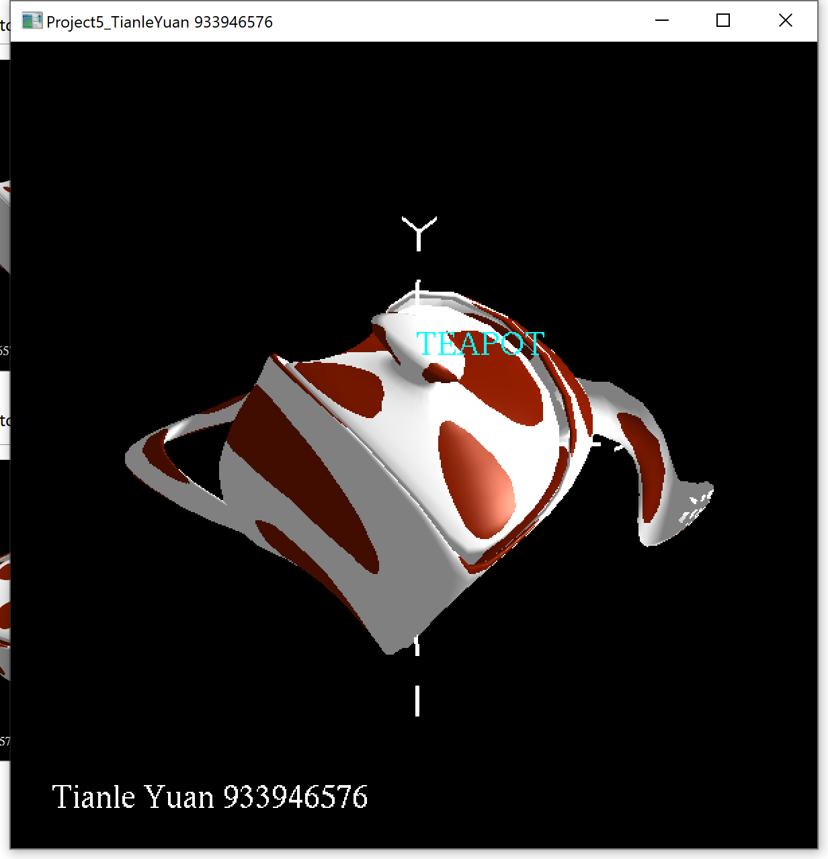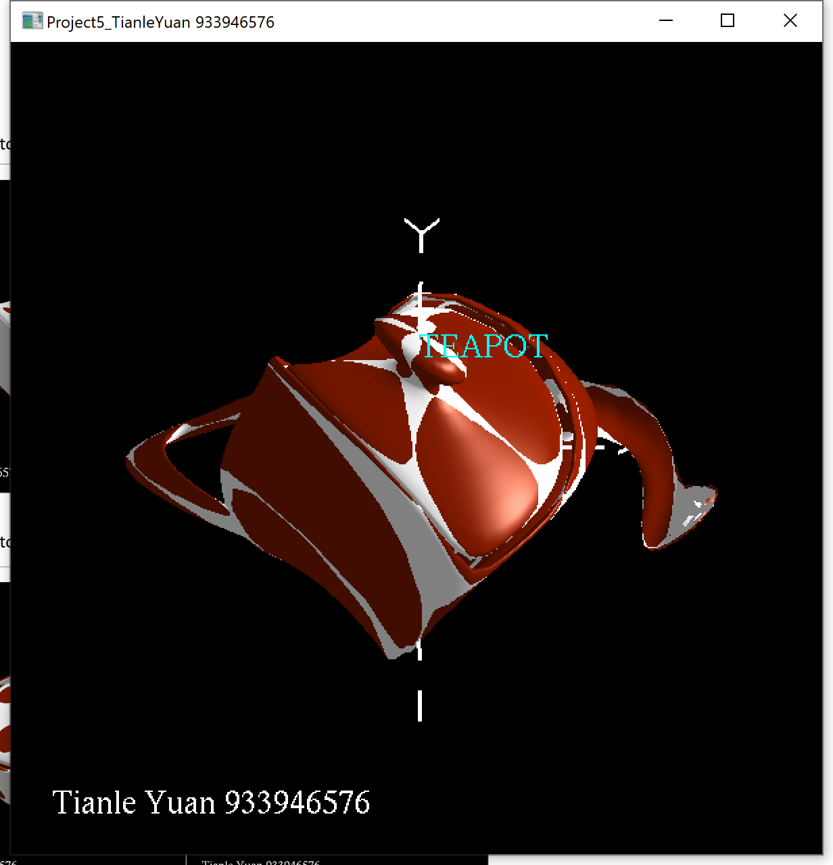

When we start to change the variables of both the vertex shader and the fragment shader.
